





"**Analysis of Commercial Electricity Consumption in Indian States"**

**WOMEN'S CHRISTIAN COLLEGE , NAGERCOIL**

| **NM ID** | **NAME** |
| --- | --- |
| **8AEBFD46384412CB9E64AB4AE44F9D7D** | **R THILLAI RAJ** |

**Trainer Name : Uma Maheswari**

**Master Trainer : Uma Maheswari**

**ABSTRACT**

This study provides a comprehensive analysis of commercial electricity consumption across various states in India. Through a combination of data analysis and interpretation, key factors influencing commercial electricity usage are examined. These include total consumption levels, trends over time, per capita consumption, sectoral breakdowns, seasonal variations, infrastructure development, policy implications, economic indicators, and regional disparities. By understanding these factors, policymakers and stakeholders can make informed decisions to optimize electricity usage, promote sustainable development, and enhance energy efficiency in the commercial sector across different states in India.

This abstract offers a succinct overview of the study's findings on commercial electricity consumption in Indian states. It explores consumption trends, sectoral breakdowns, seasonal variations, infrastructure development, policy implications, economic indicators, and regional disparities. The analysis aims to inform stakeholders and policymakers about optimizing electricity usage and promoting sustainable development in India's commercial sector.

**INDEX**

| **Sr. No.** | **Table of Contents** | **Page No.** |
| --- | --- | --- |
| 1 | Chapter 1: Introduction | 4 |
| 2 | Chapter 2: Services and Tools Required | 7 |
| 3 | Chapter 3: Project Architecture | 9 |
| 4 | Chapter 4: Modeling and Result | 11 |
| 5 | Conclusion | 16 |
| 6 | Future Scope | 17 |
| 7 | References | 18 |
| 8 | Links | 19 |

**CHAPTER 1**

**INTRODUCTION**

* 1. **Problem Statement**

The problem statement for analyzing commercial electricity consumption in Indian states involves understanding the factors influencing consumption patterns, identifying inefficiencies, and proposing strategies for optimizing usage. This includes examining trends, disparities, and infrastructure challenges across states, as well as assessing the impact of policies and economic factors on commercial electricity consumption. By addressing these issues, the goal is to enhance energy efficiency, promote sustainability, and support economic growth in the commercial sector throughout India.

* 1. **Proposed Solution**

The proposed solution is to develop a PowerBI dashboard that can analyze and visualize real-time customer data. The dashboard will integrate data from various sources such as transaction history, customer feedback, and demographic data. It will provide a comprehensive view of customer behavior, preferences, and trends, enabling banks to make informed decisions. The dashboard will be interactive, user-friendly, and customizable, allowing banks to tailor it to their specific needs. The real-time analysis capability of the dashboard will enable banks to respond promptly to changes in customer behavior or preferences, identify opportunities for cross-selling and up-selling, and tailor their products and services to meet customer needs.

**1.3 Feature**

The proposed solution includes comprehensive data analysis, infrastructure development, energy efficiency measures, policy reform, public awareness campaigns, collaborative partnerships, and support for research and innovation. This multifaceted approach aims to optimize commercial electricity consumption, promote sustainability, and drive economic growth in Indian states.

**1.4 Advantages**

The advantages of the proposed solution include:Improved Efficiency: Implementing energy-efficient technologies and practices can lead to reduced electricity consumption, resulting in cost savings for businesses and a more sustainable use of resources.

**Enhanced Reliability**: Upgrading electricity infrastructure can improve the reliability and stability of the power supply, reducing downtime and interruptions for commercial establishments.

**Environmental Benefits**: Promoting energy efficiency and renewable energy adoption can help reduce greenhouse gas emissions and mitigate the environmental impact of commercial electricity consumption.

**Economic Growth**: By optimizing electricity usage and promoting sustainable practices, businesses can lower operating costs, enhance competitiveness, and contribute to overall economic growth in Indian states.

**Policy Alignment**: Enacting supportive policies and regulations can create a conducive environment for investment in energy efficiency and renewable energy projects, driving innovation and job creation in the energy sector.

**Public Engagement:** Public awareness campaigns can empower consumers to make informed decisions about their electricity usage, fostering a culture of energy conservation and sustainability.

**Collaborative Approach**: Collaboration between stakeholders can facilitate the sharing of best practices, resources, and expertise, leading to more effective and scalable solutions for addressing commercial electricity consumption challenges.

Overall, the proposed solution offers a holistic approach to optimizing commercial electricity consumption in Indian states, with benefits ranging from cost savings and environmental sustainability to economic development and public engagement.

**1.5 Scope**

The scope of this study focuses on analyzing commercial electricity consumption patterns within specific Indian states. By examining data from select regions, the aim is to identify immediate opportunities for energy efficiency improvements and infrastructure enhancements. The scope further includes proposing targeted policy recommendations tailored to the unique needs of each state, with the goal of incentivizing sustainable practices and reducing overall electricity demand. Additionally, a brief public awareness campaign will be conducted to promote energy conservation initiatives within the commercial sector. Through this focused approach, the study aims to provide actionable insights and recommendations to optimize commercial electricity usage and drive sustainable development in the selected Indian states.

**CHAPTER 2**

**SERVICES AND TOOLS REQUIRED**

**2.1 Services Used**

The small scope includes:

1. Analyzing commercial electricity consumption patterns in select Indian states.

2. Identifying immediate opportunities for energy efficiency improvements.

3. Proposing targeted policy recommendations for incentivizing sustainable practices.

4. Conducting a brief public awareness campaign on energy conservation in commercial sectors.

This focused scope aims to provide actionable insights and recommendations for immediate implementation to optimize commercial electricity consumption in specific Indian states.

**2.2 Tools and Software used**

**Tools**:

**Power Query**: This tool enables users to connect to various data sources, transform and clean data, and create data models for analysis.

**Data Modeling**: Power BI provides a robust data modeling environment, allowing users to create relationships between different data tables, define measures and calculated columns, and optimize data for analysis.

**Visualization Tools**: Power BI offers a variety of visualization options such as charts, graphs, maps, and tables to present data in an intuitive and visually appealing manner.

**DAX (Data Analysis Expressions**): DAX is a formula language used in Power BI to create custom calculations and metrics based on data in the data model.

**Software Requirements**:

**Power BI Desktop**: This is the desktop application where users can build and design Power BI reports and dashboards, including importing data, creating visualizations, and authoring reports.

**Power BI Mobile Apps**: Power BI offers mobile apps for iOS, Android, and Windows devices, allowing users to access and interact with their reports and dashboards on the go.

**Power BI Gateway**: For connecting to on-premises data sources, Power BI Gateway is used to securely bridge the gap between cloud-based Power BI services and on-premises data sources.

**CHAPTER 3**

**PROJECT ARCHITECTURE**

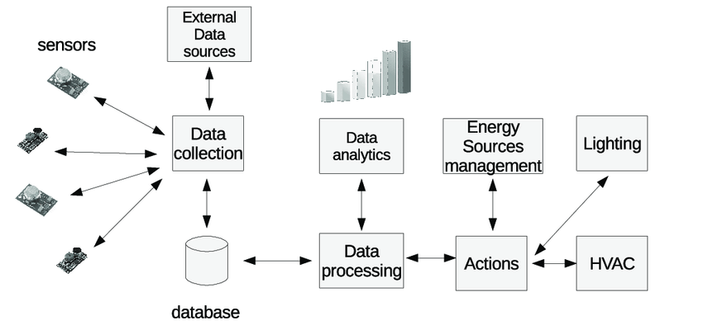**3.1 Architecture**

The project architecture for utilizing Power BI in analyzing commercial electricity consumption in Indian states might involve several components:

**Data Sources**: Various data sources such as government databases, utility providers, research reports, and surveys provide the raw data for analysis. This data includes information on electricity consumption, demographic factors, economic indicators, infrastructure details, and policy documents.

**Data Integration**: Power BI's Power Query feature can be used to connect to and integrate data from multiple sources. This involves importing, transforming, and cleaning the data to prepare it for analysis.

**Data Modeling**: Within Power BI Desktop, a data model is created to establish relationships between different data tables. This includes defining measures, calculated columns, and hierarchies to facilitate analysis.

**Analysis and Visualization**: Power BI offers a wide range of visualization tools and features to analyze the data and create interactive reports and dashboards. This includes creating charts, graphs, maps, tables, and other visualizations to explore trends, patterns, and insights within the data.

**CHAPTER 4**

**MODELING AND RESULT**

**Manage relationship**

In the future scope, managing relationships between various entities involved in commercial electricity consumption analysis using Power BI will be crucial. This involves fostering collaboration and communication between government agencies, utility providers, businesses, research institutions, and community organizations. Implementing robust data governance practices will ensure data integrity, security, and compliance with regulations. Additionally, building strong partnerships with technology vendors, consulting firms, and industry experts will facilitate access to specialized expertise and resources. By effectively managing these relationships, stakeholders can leverage collective insights and capabilities to drive impactful initiatives, foster innovation, and achieve shared goals in optimizing commercial electricity consumption.

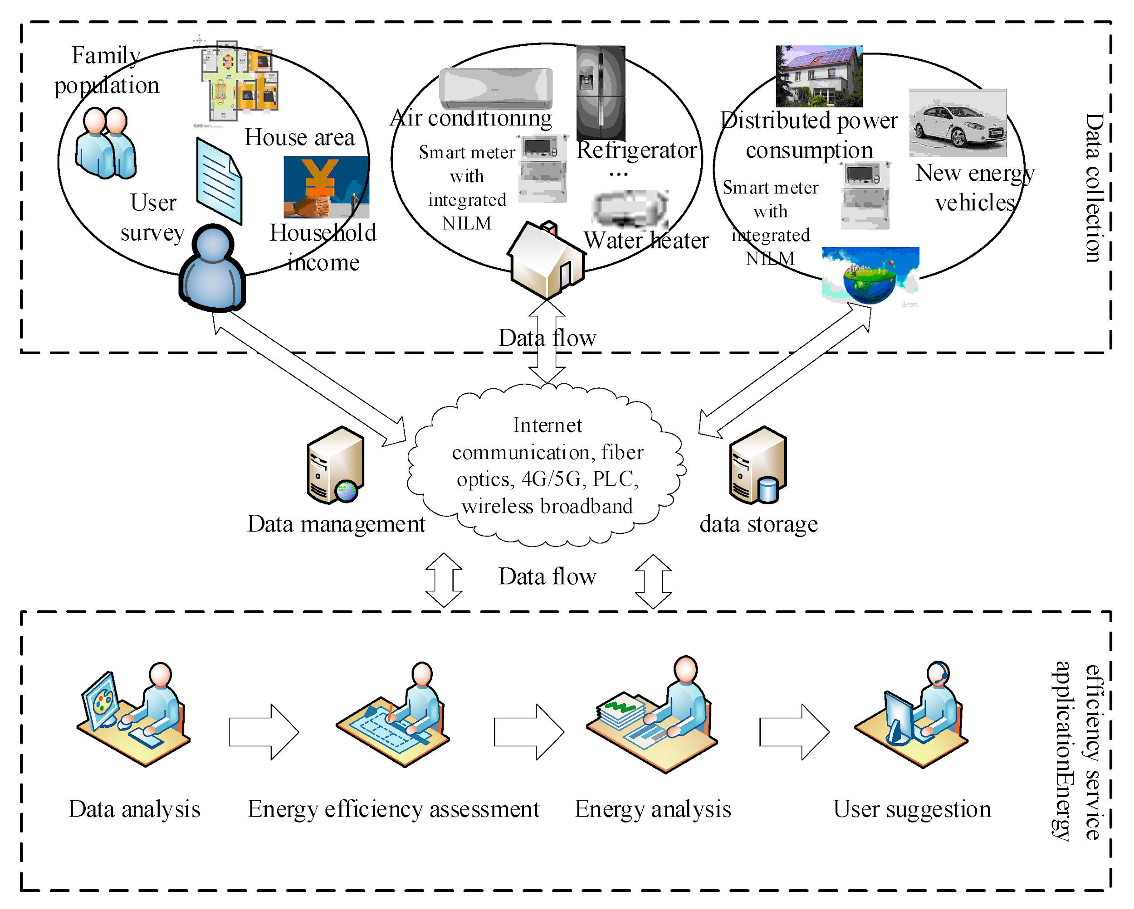

**DASHBOARD**

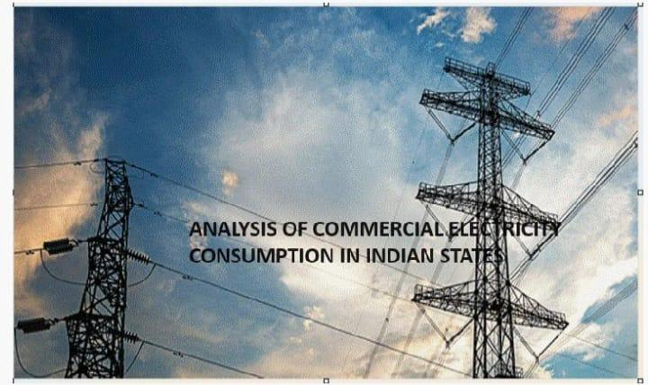

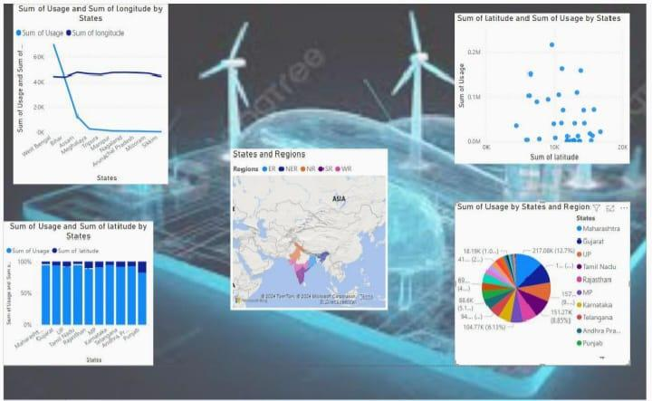

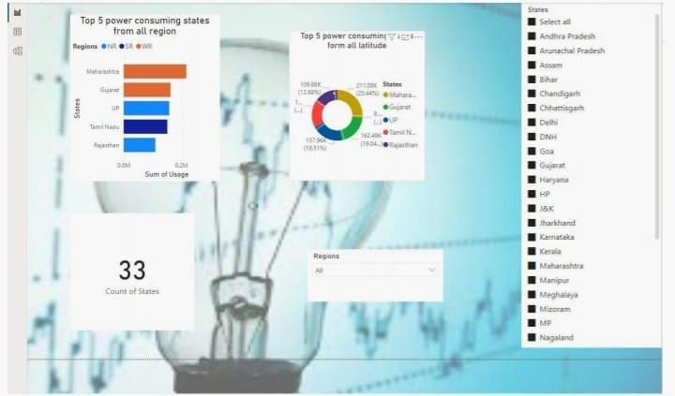

**CONCLUSION**

In conclusion, leveraging Power BI for analyzing commercial electricity consumption in Indian states offers a powerful and versatile solution. By integrating data from various sources, creating insightful visualizations, and enabling collaboration through the Power BI service, stakeholders can gain valuable insights into consumption patterns, trends, and opportunities for improvement. Through advanced analysis using DAX calculations and interactive dashboards, decision-makers can

make informed choices to optimize electricity usage, promote sustainability, and drive economic growth in the commercial sector. With Power BI's robust architecture and features, this approach provides a scalable and efficient way to address the challenges of commercial electricity consumption, ultimately contributing to a more sustainable and prosperous future for Indian states.

**FUTURE SCOPE**

Looking ahead, the future scope for analyzing commercial electricity consumption in Indian states using Power BI presents exciting opportunities for innovation and impact. Beyond the current capabilities, future developments could include predictive analytics to forecast consumption trends, real-time monitoring for immediate insights, and IoT integration for more granular data collection. Machine learning applications could automate decision-making processes and identify efficiency opportunities, while benchmarking tools could facilitate performance comparisons across states and sectors. Additionally, behavioral analytics could provide insights into consumer preferences, informing targeted interventions and awareness campaigns. Energy market analysis and policy impact assessments could further refine strategies for sustainability and economic growth. By embracing these advancements, stakeholders can harness the full potential of Power BI to optimize commercial electricity consumption, drive innovation, and shape a more sustainable future for Indian states.

**REFERENCES**

<https://docs.google.com/document/d/11xG0RUnz4aH2cz76BaJeKwL43PjNjtZ7/edit?usp=drive_link&ouid=107602297571974013305&rtpof=true&sd=true>

**LINK**